Warewashing Process (3-Bay)

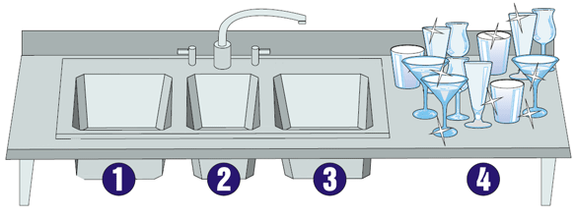

1 WASH
110ºF minimum

2 RINSE
Fresh water. Running or dip

3 SANITIZE
Chlorine:
Concentration Range | Minimum Temperature
ppm | pH 10 or less | pH 8 or less
25-49 | 120°F | 120°F
50-99 | 100°F | 75°F
100 | 55°F | 55°F

Quaternary Ammonium Compounds (QAC):
Concentration range may vary by product. Generally used between 150-400ppm. Please see product label for manufacturer’s use instructions. Use QAC test papers to check concentration. Minimum temperature of 75oF

4 AIR DRY

